Portal – Resources

# Business objective

To make resources available to users at the ‘point of need’, i.e. the most appropriate resource at the most appropriate time.

When lawyers perform legal work, they require access to common resources. These resources include precedent documents, letters, scripts, checklists, URLs, training videos, etc.

From a knowledge management perspective, it is difficult to find a resource when you need it. Resources can be filed in many different places and according to many different taxonomies, e.g. Offering, Law Area, Business area (e.g. Marketing), etc.

Ideally there is only one copy of any resource so that it can be maintained in a central place. But the resource is then linked to various contexts within portal.

One of the purposes of the Offering framework is to enable resources to be associated with Components so that they are available to the lawyer when they need the resource during the matter process.

# Association of resources

Resources can be associated at 3 different levels within an Offering:

* [Offering Category]
* Offering
* Outcomes
* Component (part of an Outcome).

I don’t think it is necessary to associate Resources with Outcomes. Components are the ‘tasks’ that produce the Outcomes. The Outcomes themselves are not ‘performed’.

At present there is no functionality to associate Resources with an Offering Category, other than Email Templates. The UI for this needs consideration. The main purpose would be to associate marketing and training materials to a particular Offering Category. This may be a later enhancement.

Metadata that can be associated with Resources include:

* **Sub Law Area**.
* **Resource type**, e.g. offering folder, form, letter, document, URL, email template, checklist, Strategy Paper, video, website, etc.

## Single resources

A single resource can be linked to more than one of these categories. However, we only ever want one copy of the resource in the system at any one time. For this reason, Resources are not hard coded in their association with any one entity. Entities should reference resources, rather than the other way around.

## Roll-up associations

When setting up Offerings and Resources, Resources should ideally be linked with Components, being the lowest tier in the information hierarchy.

For example, in the ‘Offering Category->Offering->Outcome->Component’ hierarch, the best place to link a Resource would at the Component level. However, if the Resource is used in several Components within an Outcome or Offering, it may be better to link it higher up the hierarchy, e.g. to the Offering.

Offering Category

Offering [Possible link here]

Outcome

Component [Possible link here]

However, all Resources should also be easily available at higher levels within the hierarchy. For example, if a document is associated with a Component, you should be able to access that document from the higher associated Outcome and Offering. Put another way, if you open a particular Offering, you can see all the Resources associated with each Outcome and Component within that Offering.

Offering [Roll-up of Resources associated with all Outcomes]

Outcome [Roll-up of Resources associated with underlying Components]

Component [Resources]

# Storing resources

There should only be one copy of a Resource within Portal.

The single Resource can then be linked to various entities within Portal, e.g. Offerings, Components, etc. The link is from the entity to the Resource.

Many of the Resources will be URLs. These link to external resources, such as webpages and remote documents. There are different categories of URLs, e.g. Forms, Metrics, Documents, Websites.

Each Resource should have relevant fields and metadata relevant to its type.

# Types of Resources

The Portal uses various types of Resource. Each Resource type is described below.

## VD Offering Folder

A VD **Offering Folder** is a folder on SharePoint (this is a URL link). The VD Offering Folder contains artifacts (such as documents) that relate to the delivery of a particular Offering. For example, precedent documents, checklists, etc.

Currently you can associate and access a VD Offering Folder when you are designing a particular Offering in Portal:



This is found under the Offering detail view.

However, when you are in a Matter, you cannot easily access the Offering Folder(s) associated with the Offerings being delivered in the Matter. Currently you need to click on the Offering link within the Matter ‘Info’ tab, which takes you to the Offering detail view, and then you need to click on the SharePoint Folder link in the top-right hand corner. We need to include direct links to the associated VD Offering Folders within a Matter (as discussed below).

## Forms

Form Resources are links to Syntaq forms.

Syntaq forms currently have their own tab within Portal where they are imported and set within Portal.

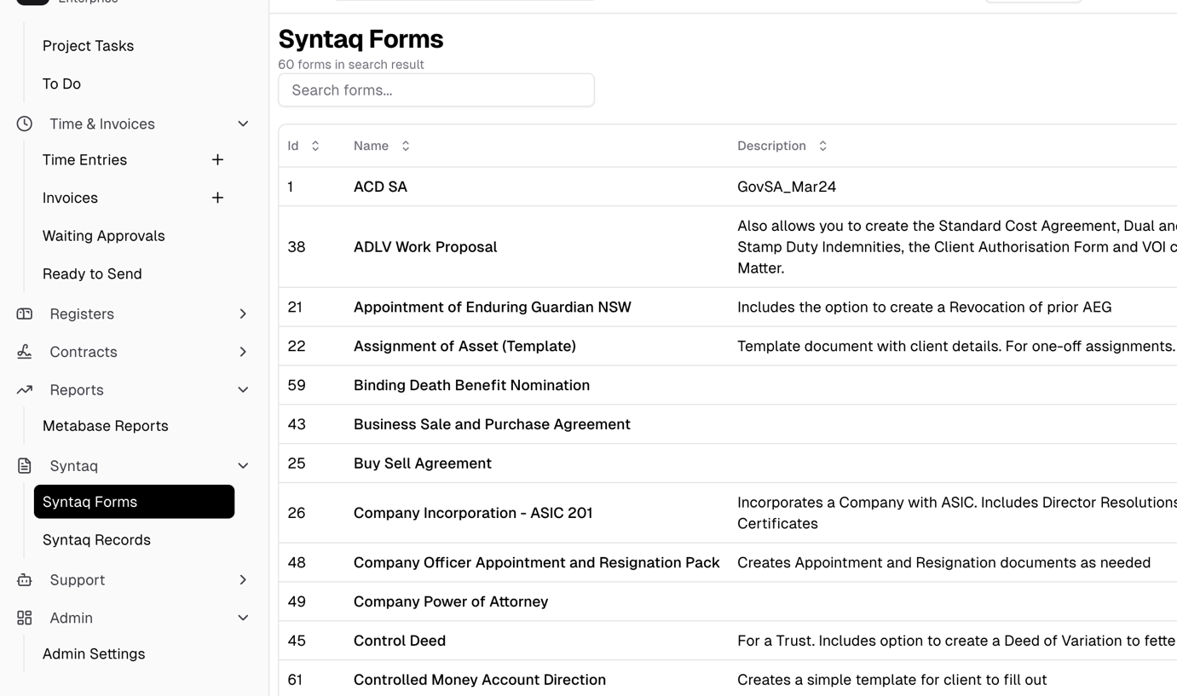

You can associate a Syntaq form within a Component when designing an Offering:



## 

You can then access the relevant Syntaq form when delivering an Offering under the relevant Component tab:



[NOTE BUG – Associated Resources for this Component are not showing.]

There is currently no way to see the Syntaq forms associated at the higher Offering level with a Matter. This is because Matters do not currently have a Resources tab (see below)

## Template Emails

Template Emails are a specific type of Resource within Portal.

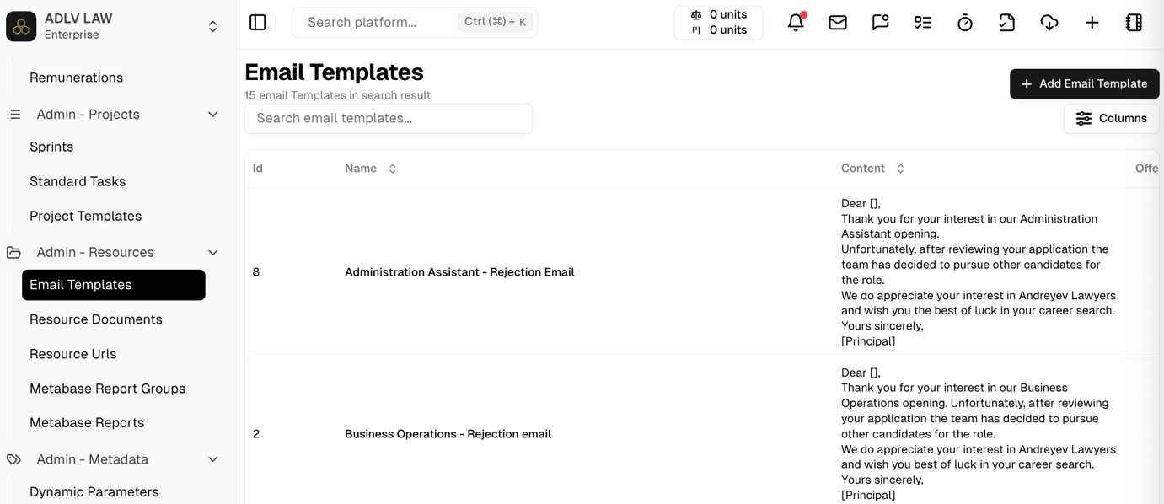



The UI for creating and managing Portal emails needs upgrading, but it is functional.

Template Emails are only associated with an **Offering Cateogry**, not individual Offerings or Components. Template emails should be able to be linked to Offerings and Components.

Furthermore, a template email is currently hard-coded associated with an Offering Category, when the Offering Category should be associated with the email (as per pattern above).

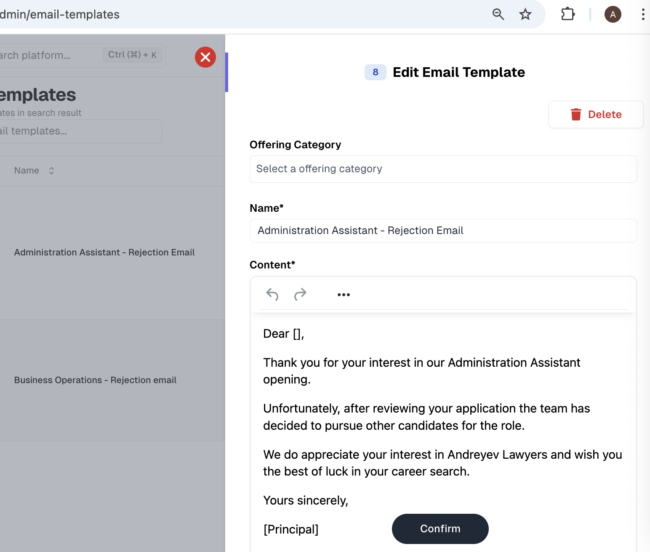



The only place you can access these templates is via the draft new email button in the top navigation bar. There is no way to start an Email Template from within an Offering or Matter. Furthermore, there is no auto filter of the associated Email Templates.

## Documents

Portal has a function to act as a ‘document store’. You can upload documents and store them as a Resource available within Portal.

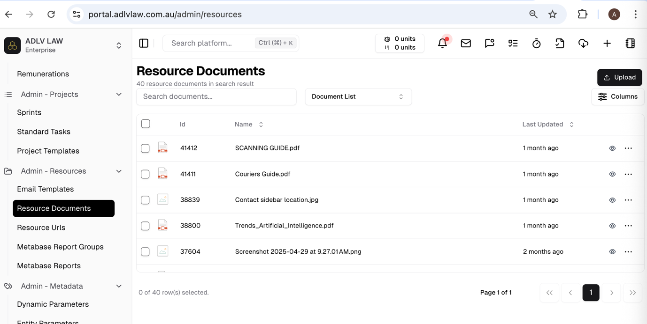

You can add metadata to a Document that includes an Offering Category. Once again this is the wrong direction for association. We should associate a Document with an Offering from within the Offering – this is also possible.



A Document can be associated with an Offering (at the Offering level):



A Document can also be associated with an Offering at the Component level:



The associated documents is visible within a Matter that is associated with the Offering:



There is currently no way to see the Documents associated at the higher Offering level within a Matter, (this is why we need a Resource tab at the Offering level).

## URLs

You can define and store URL addresses in Portal.

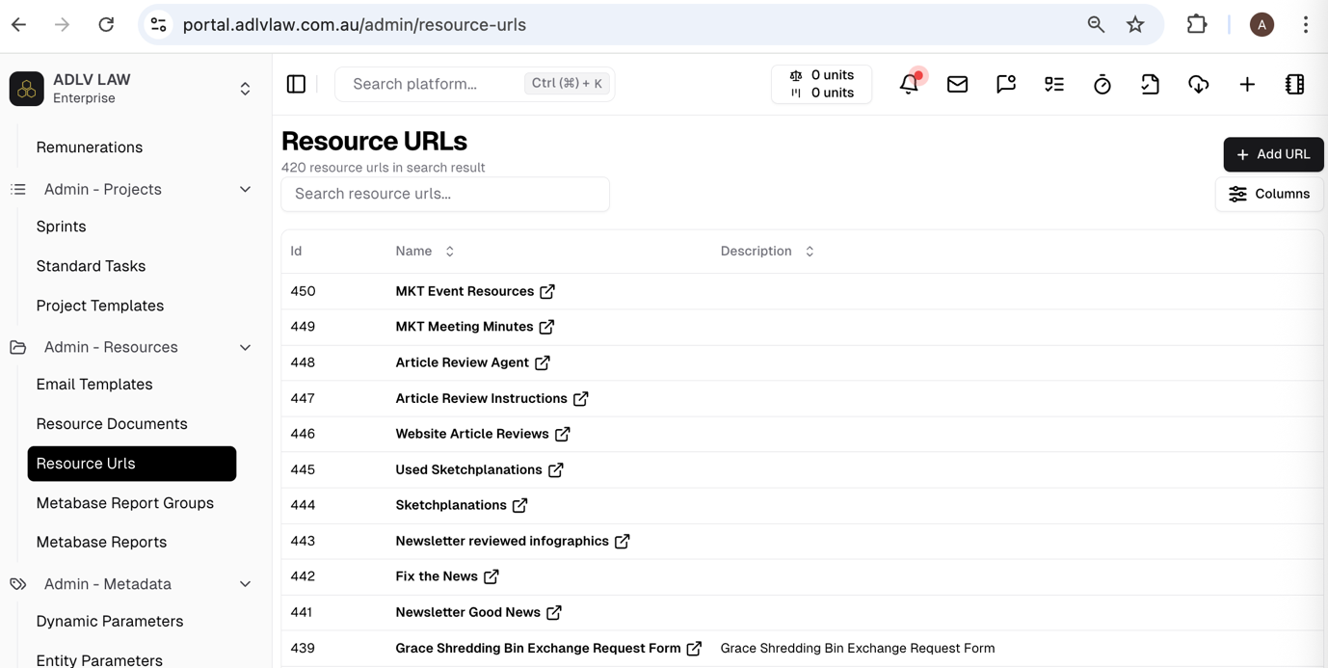

These are not associated with any particular entity when being set up (which is appropriate):

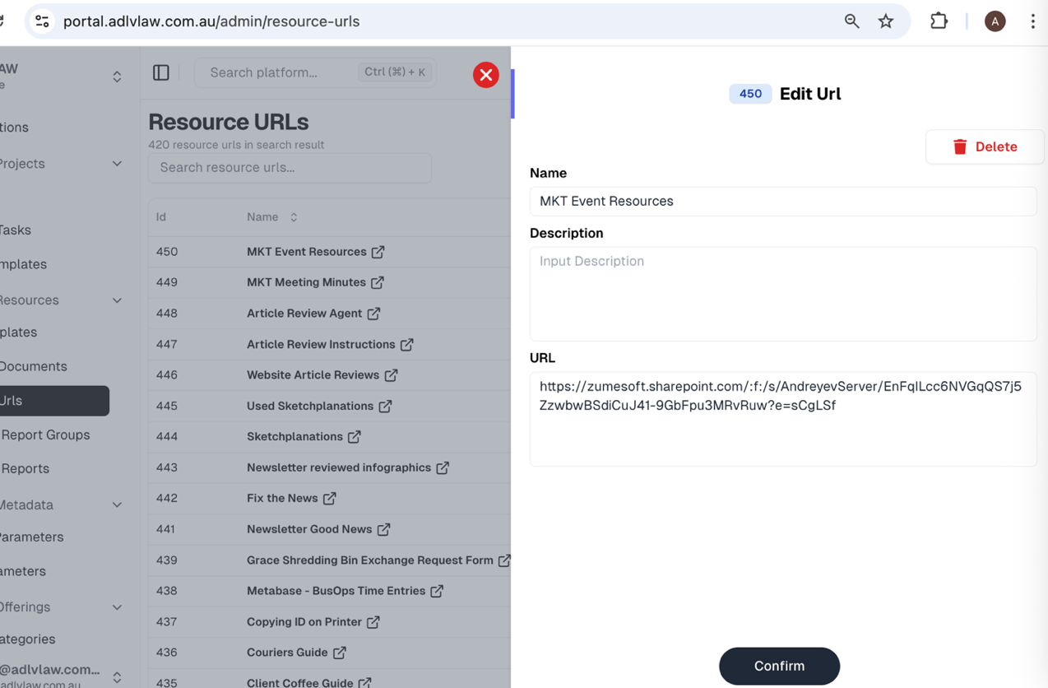

You can associate a URL with an Offering at the Offering level:



You can also associate a URL with an Offering at the Component level:

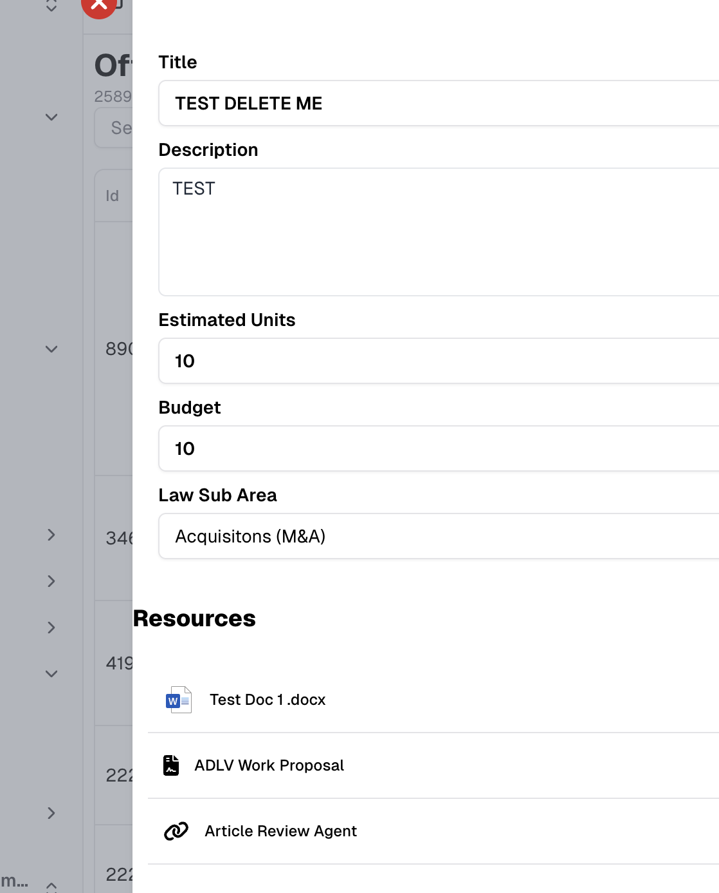



You can access the URLs associated with a Component within a Matter:



There is currently no way to see the URLs associated at the higher Offering level within a Matter. This is why we need to introduce the Resources tab for Matters.

## Videos/Media

We currently do not have a Resource category for video content.

This can be a type of URL.

# Matter Resources tab

We need a new **Resources tab** in the Matter detail display.

The purpose of this tab is to display all the Resources available to a user for the Matter in a logical way and in a manner that reflects the point-of-need principle.

## VD Offering Folder links

When an Offering is associated with a Matter, we need to be able to access the VD Offering Folder directly from within the Matter.

The Resource tab needs to display a link to each **VD Offering Folder** for each linked Matter. The links need to adopt the Offering name, so it is clear which folder is being accessed when you click on the button.

## Display of other Matter Resources

The Resources tab within the Matter should also display a hierarchical map of the Resources available for the Matter:

**Offering resources**

Resources associated at the Offering level

**Outcome 1 resources**

Resources associated at the Outcome 1 level

**Component 1 resources**

Resources associated at the Component 1 level

**Component 2 resources**

Resources associated at the Component 2 level

**Outcome 2 resources**

Resources associated at the Outcome 2 level

**Component 1 resources**

Resources associated at the Component 1 level

This is the current **Offering Resources** tab in the Admin-Offering designer. The Resource tab for Matters should be similar to this structure.

On the left-hand side are resources only associated at the Offering level. On the right-hand side are Resources associated with each Component:

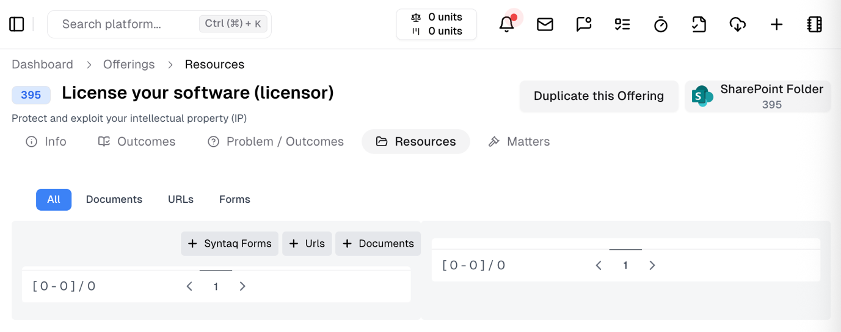



# Component Resources

Currently a user can associate a Resource with a Component in the Offering designer:

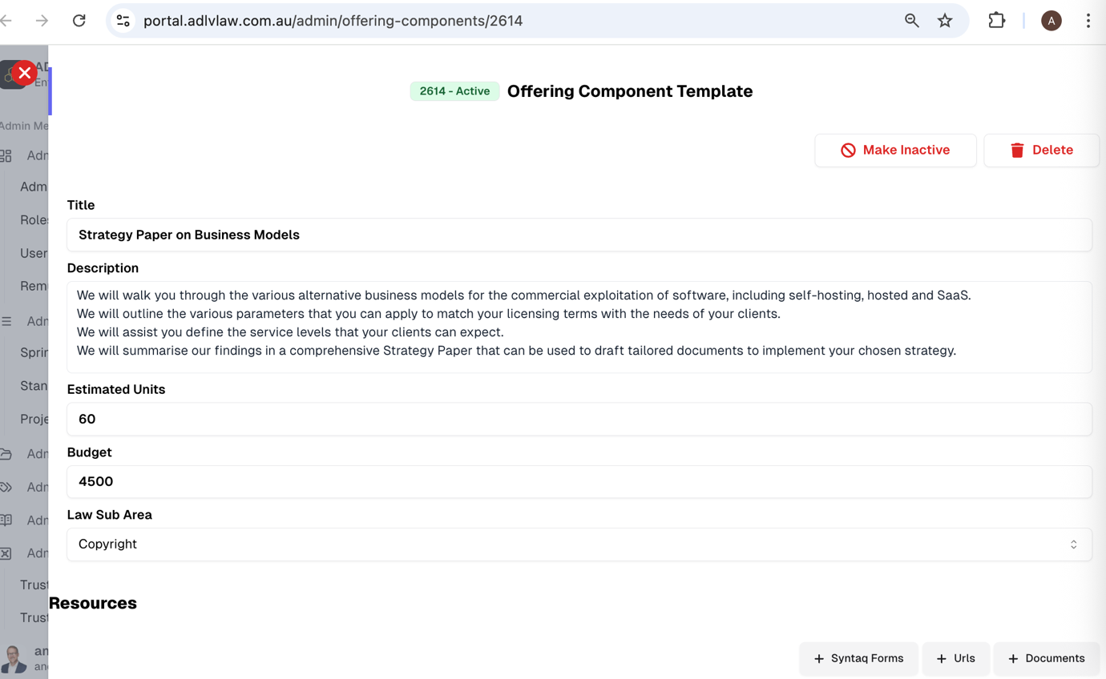



[Not all Resources are available, e.g. Template Emails, Video]

When a Component is copied into a Matter, the Component Resource is made available within the Matter Components:

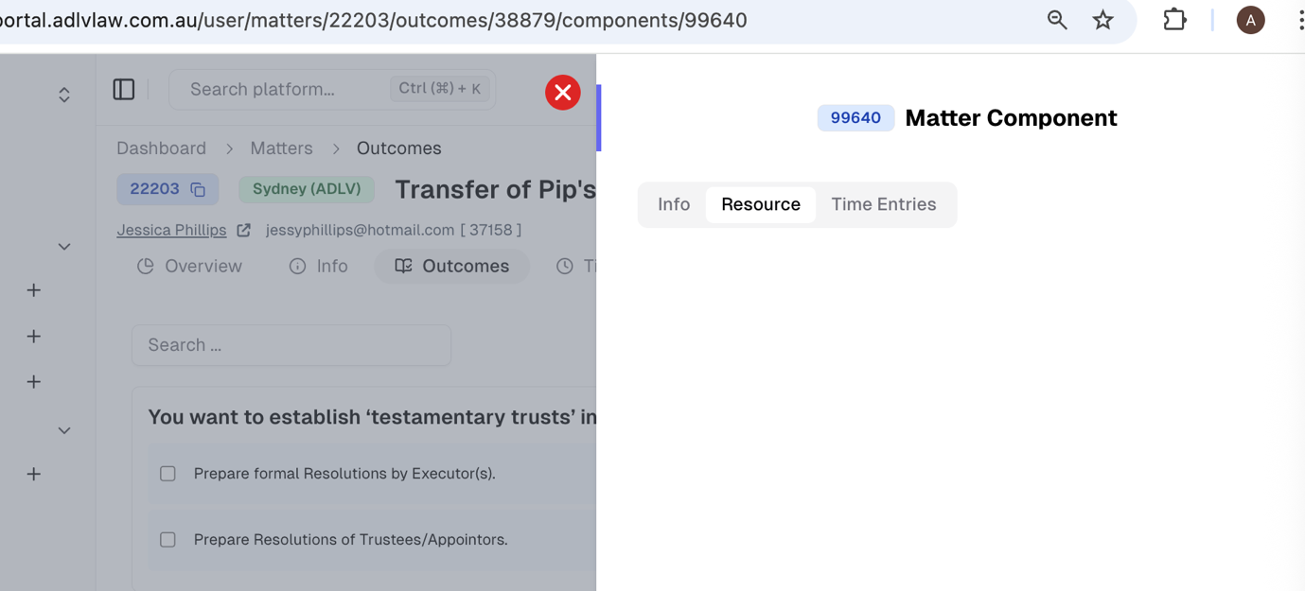



[Note the bugs: the Syntaq forms are not showing here.]

# Outcome Resources

The Resources associated with the Components within an Outcome should also be displayed in this view:

List Resources within Component here.